The Title is : "Comprehensive Water Quality Assessment and Potability Prediction using Multi-parameter Analysis”
- The Problem Statement : Objective: The objective of this machine learning problem is to predict whether a given set of water quality parameters meets the potability criteria or not based on the provided features.
Sample data, use this image as sample to read and identify the columns, check on which columns the target is dependent, and which columns are unneccessary,
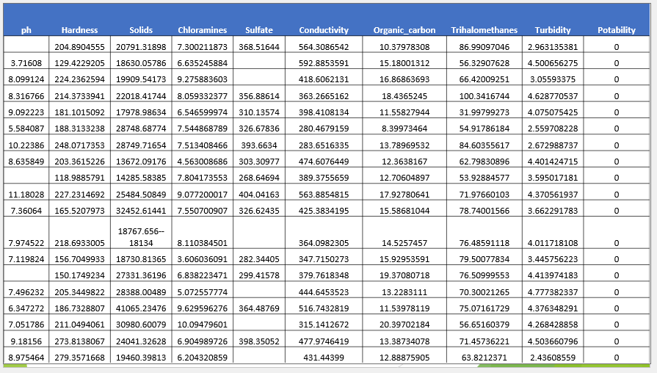
->I want to analyse each and every column, Potability is the Target column, and the rest are the features columns.
-> I want to check which columns are important to determine the Potability
(0/1) of water.
-> If the Potability is ‘1’, then the water is drinkable, else not drinkable.
-> I want to do data preprocessing, data analysis/visualization,EDA(i want good images to add to my PPT)
,give statistical understanding, check for null values, check if data is imbalance or not and correct it if it’s imbalance, and check for outliers if neccessary.
-> Use atleast 2 or 3 data models(with different algorithms like Random Forest, Decision tree , etc) to check which is more accurate.
-> Calculate, accuracy, check if it’s over fitting, give the confusion matrix.

